North Lincolnshire Council
Daily Event Analysis
6th October 2010

Overview
Low Santon measured a daily mean PM₁₀ concentration of 75µg/m³ on Wednesday the 6th October 2010 exceeding the allowed 50µg/m³ as a daily mean. A check of the data has revealed that concentrations of PM₁₀ began to increase at 12:00 and fell at 17:00. During this 5 hour period concentrations at the Low Santon TEOM remained at over 100µg/m³. The Dawes Lane Coke Oven (DLCO) Osiris measured a daily mean concentration of 37µg/m³. The Osiris did not measure the same elevated levels that the Low Santon TEOM witnessed between 12:00 & 17:00

Met Conditions
Consistent SW winds were observed throughout the day. The wind within the 5 hour period of focus ranged between 231° and 248°. Wind speeds were relatively low averaging at 2.5 m/s. The period of focus averaged at 4.1m/s. The highest wind speed in this period was 5.1m/s in which the concentration of PM₁₀ reached 226µg/m³. Rain was measured in the morning but cleared to a bright warm afternoon.

Episode Wind Range

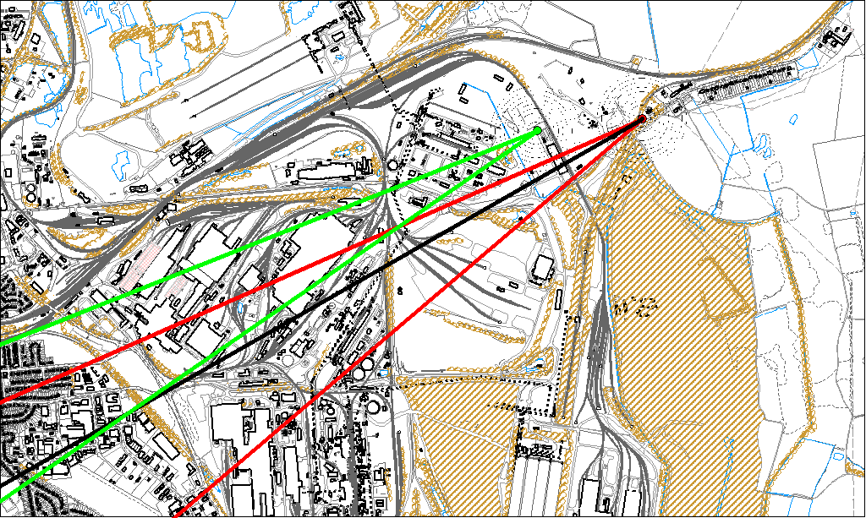

Potential Sources
The above map shows the Low Santon Monitoring Station (indicated by the red lines) and the DLCO Osiris (indicated by the green). The black line within the red shows the wind direction of the highest concentration during the 5 hour period of focus.

As the Osiris was not subject to the same elevated levels at the TEOM, it is likely that the source of the episode did not originate from within the wind sectors relevant to the Osiris (green lines). By removing the area of the TEOM wind sectors also affecting the Osiris we can identify specific areas on site that may have been responsible for the exceedance.

The likely areas include;

- Tarmac
- The Redbourne Steel Stocking Area

The black line indicates the highest measured concentration during this period. This runs through the Tarmac site and through the Redbourne Steel Stocking Area.

